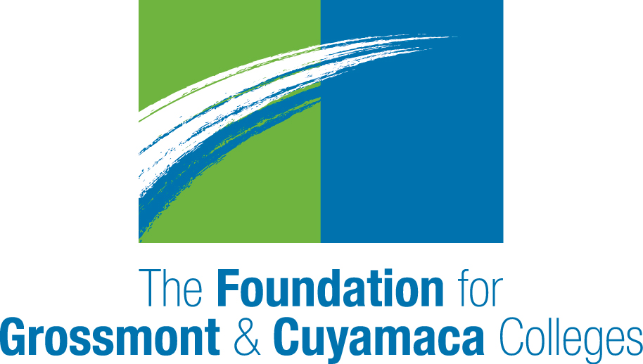

2017-18

Innovation in Student Success Grant Grants

The Foundation for Grossmont & Cuyamaca Colleges (FGCC) is pleased to offer the first-ever Innovation in Student Success Grant for the 2017/18 academic year. The FGCC Board of Directors will select one applicant (team/program) from each college (Grossmont, Cuyamaca) will receive a $5,000 grant to support innovative programs, ideas, and/or approaches.

Innovation in Student Success Grants foster projects that:
- Engage new and/or diverse audiences.
- Use innovative approaches to forge partnerships and fulfill the goals of the Grossmont-Cuyamaca Community College District and its respective Colleges.

Grant Guidelines
- Applications must demonstrate how the funds will have an impact on the education of our students or their experience at the College.
- Grants may be used for costs such as: speakers, films, educational/cultural performances, equipment and software, course field trips, printing for student materials, books for special programs to benefit students, event costs for student-related programs, teaching materials, professional development (if it can be tied to student success measures).
- Grants may not be used for costs such as: scholarships, alcohol, sponsorship of other organizations, funding for religious or political purpose, items for personal use, salaries and benefits.
- Requests for funding must be made using the attached form.
- Applications must be reviewed and approved by the College president prior to submission.
- Applications must be sent by email (scan signed document); paper applications will not be accepted.
- Applications are due by 5 p.m. on May 5, 2017. (Grant awards for 2018 will be dependent on future unrestricted contributions to FGCC.)
- Awards will be announced in June.
- Funds should be expended between July 1, 2017, and June 30, 2018.
- Innovation in Student Success Grant recipients WILL BE required to submit a summary report documenting how the funds were used and outcomes obtained within 60 days of project completion. Video report submission for promotional purposes is strongly encouraged.
- Please limit an Innovation in Student Success Grant Application to no more than 4 pages.
- Applicants must submit an Innovation in Student Success Application in order to receive consideration.
- Applicants may additionally apply for a College Support Grant ($1,000) using the separate guidelines and application.

2017-18
Innovation in Student Success

APPLICATION

Department Name:

Cuyamaca: ______ Grossmont: ______

Name and Title of Project Leader:

Email: Work Phone:

Name of Department Chair/Program Director:

Email: Phone:
______________________________________________________________________

Title of Request:

Description of Specific Purpose of Funding Request:

Amount Requested (up to $5,000 maximum):

Is this request also being funded by the College budget? No Yes

If YES, how much funding is the program receiving during the 2017-18 academic year?

If the cost of the project is more than $5,000 and not funded by the college, where will you obtain the remaining funds? Please identify sources and amounts below.

Please provide the expenditure breakdown for requested funds.

How will this project benefit the educational outcomes of our students or their experience at the College?

If funded, will this project be sustainable after the first year? Explain.

How does this project address one or more of the following:
- Engage new and/or diverse audiences.
- Use innovative approaches to forge partnerships and fulfill the goals of the Grossmont-Cuyamaca Community College District and its respective Colleges.

Evaluation
- Explain how you will evaluate the success of this program.
- Explain how you will use data to demonstrate the impact of this program.

Do you acknowledge that, if funded, you will be required to provide a summary report documenting how the funds were used and outcomes obtained within 60 days of project completion to the FGCC? Video report submission for promotional purposes is strongly encouraged.
Yes No

______________________________________________________________________
Signature of Applicant DATE

Signature, Dean/Director (Supervisor) DATE

Signature, Vice President DATE

Signature, College President DATE

TO BE CONSIDERED, ORIGINAL COMPLETED APPLICATIONS (WHICH MUST INCLUDE ALL OF THE SIGNATURES INDICATED ABOVE) MUST BE RECEIVED IN THE FOUNDATION OFFICE NO LATER THAN 5:00 PM ON FRIDAY, MAY 5, 2017.

