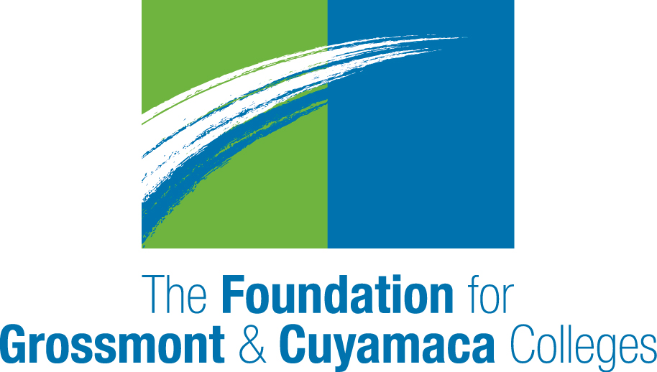
2017-18
College Support Grants

The Foundation for Grossmont & Cuyamaca Colleges is pleased to offer College Support Grants for the 2017-18 academic year.

The goal of this program is to support existing programs, provide resources to augment existing funding, or replace funds lost due to budget cuts. However, our bottom-line goal is to fund programs that have a direct impact on our students.

Guidelines

- Grants of up to $1,000 are available.
- Applications must demonstrate how the funds will have an impact on the education of our students or their experience at the College.
- Grants may be used for costs such as: speakers, films, educational/cultural performances, equipment and software, course field trips, printing for student materials, books for special programs to benefit students, event costs for student-related programs, teaching materials, professional development (if it can be tied to student success measures).
- Grants may not be used for costs such as: scholarships, alcohol, sponsorship of other organizations, funding for religious or political purpose, items for personal use, salaries and benefits.
- Requests for funding must be made using the attached form.
- Applications must be reviewed and approved by the College president prior to submission.
- Applications must be sent by email (scan signed document); paper applications will not be accepted.
- Applications are due by 5 p.m. on May 5, 2017. (Grant awards for 2018 will be dependent on future unrestricted contributions to FGCC.)
- Awards will be announced in June.
- Funds should be expended between July 1, 2017 and June 30, 2018.
- Grant recipients may be required to submit a summary report documenting how the funds were used and outcomes obtained within 60 days of project completion.
- Applicants must submit a College Support Grant Application in order to receive consideration.
- Applicants may additionally apply for an Innovation in Student Success Grant ($5,000) using the separate guidelines and application.

Questions about the program should be directed by email to FGCC at foundation@gcccd.edu

2017-18 College Support Grants
Application

Department Name Cuyamaca Grossmont

Name and Title of Applicant

Email Work Phone

Name of Department Chair/Program Director

Email Phone

Title of Request

Description of Specific Purpose of Funding Request

Amount Requested (up to $1,000 maximum)

Is this request also being funded by the College budget? No Yes

If YES, how much funding is the program receiving during the 2017-18 academic year?

If the cost of the project is more than $1,000 and not funded by the college, where will you obtain the remaining funds? Please identify sources and amounts below.

Please provide the expenditure breakdown for requested funds.

How will this project benefit the educational outcomes of our students or their experience at the College?

Do you acknowledge that, if funded, you may be required to provide a summary report documenting how the funds were used and outcomes obtained within 60 days of project completion to the FGCC?
Yes No

______________________________________________________________________
Signature of Applicant DATE

Signature, Dean/Director (Supervisor) DATE

Signature, Vice President DATE

Signature, College President DATE

TO BE CONSIDERED, ORIGINAL COMPLETED APPLICATIONS (WHICH MUST INCLUDE ALL OF THE SIGNATURES INDICATED ABOVE) MUST BE RECEIVED IN THE FOUNDATION OFFICE NO LATER THAN 5:00 PM ON FRIDAY, MAY 5, 2017.

